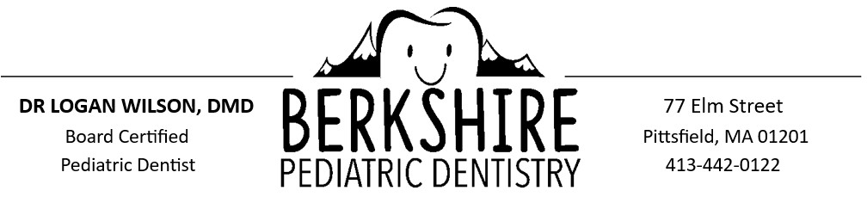

Pt Name: ___________________________________________________ Date of Birth: ____________________
If your child has an Autism Spectrum Disorder, please help us make this the best experience possible for him/her by answering the following questions:
How would you describe your child’s ASD: Mild Moderate Severe Don’t Know
How does your child communicate?
- Language understanding Limited Some Most
- Speech Non-Verbal Limited Verbal Highly Verbal
- Complies with simple instructions Rarely Sometimes Usually
What activities can your child complete on their own:
Restroom Bathing Dressing Hair brushing Toothbrushing
Is your child sensitive to any of the following:
Loud Noises Bright Lights Unfamiliar smells Unfamiliar Tastes
What reward system works best for your child? _________________________________________________________
__________________________________________________________________________________________________
Has your child had any negative experiences with a doctor or dentist: No Yes
If yes, please explain: __________________________________________________________________________
What can we do to make this visit easier for your child? ___________________________________________________
__________________________________________________________________________________________________
Does your child express any concerns about aspects of his/her teeth or mouth? No Yes
If yes, please explain: __________________________________________________________________________
Is there anything else you would like us to know about your child? __________________________________________
__________________________________________________________________________________________________
Thank you!

